_T1071 (SafeCap+)

_D5.3 Phase 02 evaluation feedback and strategy

# Introduction

The on-going series of the SafeCap projects (sponsored by EPSRC and RSSB) focus on improving capacity of railway nodes (junctions and stations) while ensuring their safety [1]. The projects have now developed a formal approach to safety verification, an integrated tooling environment that supports a domain-specific interface to help signalling engineers and a simulation tool used to calculate node capacity for various traffic scenarios. This work serves as a sound foundation for the development of the SafeCap train advisory system. This is now the area of the on-going work in the RSSB SafeCap+ project (2014-2016), which aims to develop novel modelling techniques and tools that support and explore integrated and efficient dynamic capacity of networks and nodes, including an energy plug-in to estimate the energy usage implications of proposed service patterns.

This deliverable contributes to WP05 (Evaluation and Strategy). Sections 2-5 evaluate the models and tools developed, which leads to the definition of an implementation strategy for market uptake in section 6.

# WP01

???

# WP02

???

# WP03: Modelling energy

## Overview

WP03 described the SafeCap+ work that developed a qualitative model to capture train energy expenditure over a track layout, which is now being used as an integral part of the SafeCap toolbox to provide richer advice output. This section describes the final (Phase 02) evaluation of this energy plug-in, using a real-world case study built from information supplied by the project’s industrial partners.

The evaluation criteria and validation methodology were described in deliverables D5.1 and D5.2 respectively [2, 3]. The process is briefly summarised in Figure 1: test scenarios were designed and then simulated in OpenTrack, an existing commercial multi-train simulation tool, and these results were used to validate the output of the SafeCap toolset.

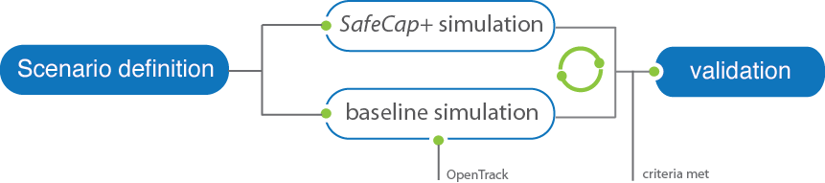

Figure 1. Validation approach

Deliverable D3.2 [4] described the real-world case study, and the development of test scenarios for the Phase 02 evaluation. Seven different scenarios were defined, each illustrating different ways of dealing with conflicts caused by late-running trains, including changing the order of trains passing a junction and the use of Standalone or Connected Driver Advisory Systems. These scenarios were specifically designed with the aim of illustrating potential traffic management issues in a representative environment.

Section 4.2 compares the results from the SafeCap toolset against the baseline simulation results from OpenTrack, and the conclusions from the evaluation are detailed in section 4.3.

## Results

(Table/graphs to compare OpenTrack and SafeCap)

## Conclusions

(Conclusions for comparison)

# WP04

???

# Future strategy

(Development of a strategy for the future use of the SafeCap+ outcomes and their contribution to the FuTRO challenges)

# References

[1] Iliasov, A., Lopatkin, I., Romanovsky, A., *SafeCap: advanced computer science techniques for railways of tomorrow*, in *EURAILmag*. 2013. p. 76-78.

[2] Project Deliverable D5.1 Definition of Evaluation Criteria. SafeCap+ Project. T1071 (SafeCap+). RSSB, January 2015.

[3] Project Deliverable D5.2 Phase 01 evaluation feedback. SafeCap+ Project. T1071 (SafeCap+). RSSB, August 2015.

[4] Project Deliverable D3.2 Tool support for modelling energy impact on performance. SafeCap+ Project. T1071 (SafeCap+). RSSB, September 2016.